Basic Unix and Web Server setup
We will be using Apache for our web server. The Apache web server is among the most popular web servers in the world. It is well documented, and has been in wide use for much of the history of the web, which makes it a great default choice for hosting a website.
Follow the LAMP document instructions to install Apache if you have not already done so.

Global web pages
Global web pages (i.e. web pages not associated with a user account) are stored in the directory /var/www/html.
To browse to these web pages, type in a browser’s address bar the ip address of the web server followed by the name of the webpage you want to access separated by slashes /. For example the URL address 192.168.1.163/index.html accesses the index.html webpage on the server whose ip address is 192.168.1.163. If you do not specify a webpage name and just enter the ip address, the default webpage to load is index.html.
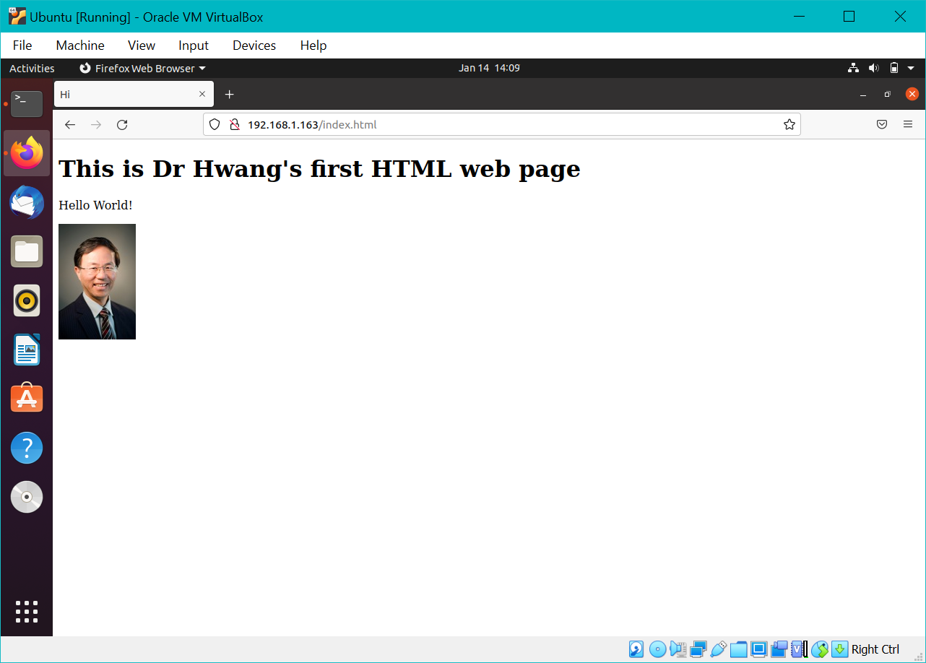
If you put web pages in subdirectories under /var/www/html then you need to specify the path to the web page in the address, for example, 192.168.1.163/products/orange.html, will retrieve the webpage orange.html under the products directory.

User web pages
User web pages are stored in the user’s home directory under public_html.
To enable this, execute the a2enmod command and then restart apache
$ sudo a2enmod userdir
$ sudo systemctl restart apache2
To enable PHP files stored in public_html, edit the file /etc/apache2/mods-enabled/php7.4.conf (replace the version number with the installed version number). At the end of the file, comment out the lines from <IfModule …> to </IfModule>. Restart apache with the systemctl command shown above.
Browsing to the address hwang.lasierra.edu/~enoch/index.html will bring up the webpage index.html in the directory public_html in user enoch on server hwang.lasierra.edu. Again the file name index.html is optional. The full path to this file is /home/enoch/pubic_html/index.html.
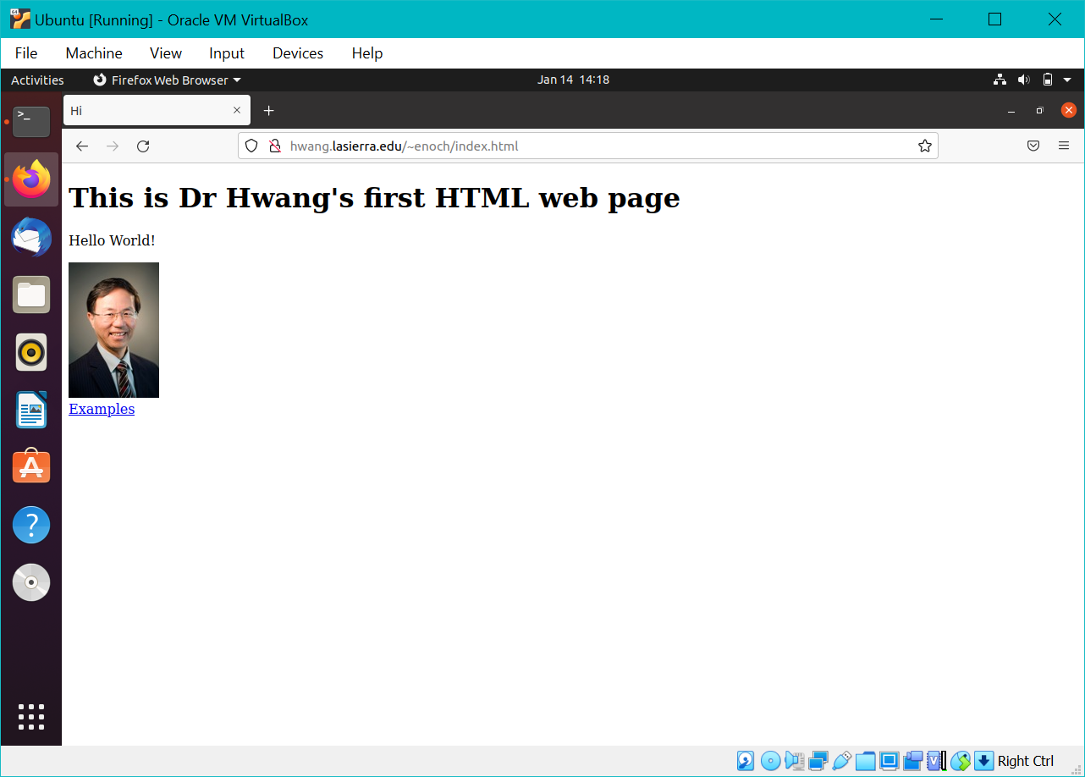
Refer to the table at the end of this document for a list of the commonly used Unix commands. In your Ubuntu system open up a terminal window.

Creating your first web page
Change directory to /var/www/html.
Create a html file named MyFirstHTML.html
$ cd /var/www/html
$ sudo nano MyFirstHTML.html
Type in the following html code in the file and save it.
<!DOCTYPE html>
<html>
<head>
<title>Hi</title>
</head>

<body>
<h1>This is Dr Hwang's first HTML web page</h1>
<p>Hello World!</p>
<img src="Enoch.jpg" alt="Dr Hwang" width="107" height="160">
<img src="http://hwang.lasierra.edu/Enoch.jpg" alt="Dr Hwang" width="107" height="160">
</body>
</html>
Browse to this webpage with the address 192.168.1.163/MyFirstHTML.html. Replace the ip address with your ip address. You will see that the image has a broken link because the file Enoch.jpg does not exist in your directory.

Port forwarding through router
With your current setup, you can only browse to your webpages from inside your router/home. If you connect to the internet from outside your router you will not be able to get through your router’s firewall and to your server. For example, from where I am, I can’t browse to your webpages. A quick way to see that is to turn off the wifi on your phone and just use your cellular data, and try to browse to your webpage from your phone. You wouldn’t be able to get to the webpage. But if you turn your wifi back on then you should be able to browse to it. (Do you know why that is so?)
What you need to do is to do a port forwarding on your router to open a port through the firewall. Every router’s setup user interface is different and I can’t cover all cases, but the idea is the same. The following instruction is for a Linksys router.
- Browse to your router’s webpage. The ip address is usually 192.168.1.1.
- Enter the router’s admin username and password. The default username is blank and the default password is admin. For other routers, just google for the default username and password for your brand.
- Go to the Settings page.
For other routers just find where Port Forwarding is, or google for Port Forwarding instructions for your router and continue with step 8 below.
- Click on the Security tab.
- Click on the Apps and Gaming tab.
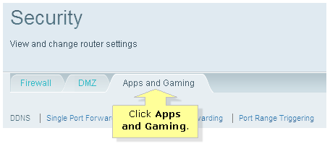
- Click Single Port Forwarding.
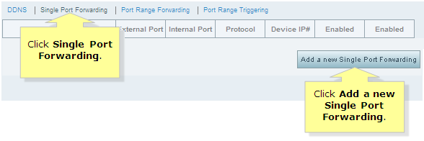
- Click Add a new single port forwarding
- Enter in the correct port you want to forward. The information that you need to enter in is the same for all router brands.
  - Application name: type in any name you like, for example, web
  - External port: 80.
  - Internal port: 80.
  - Protocol: Both UDP and TCP. If it doesn’t give you the Both option, then you need to add two lines, one for UDP and one for TCP.
  - Device IP: the ip address of your server. In my case it’ll be 192.168.1.163
Make sure you save the changes.
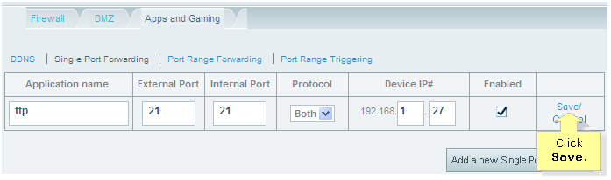

Port forwarding through VirtualBox
Reference: https://nsrc.org/workshops/2014/btnog/raw-attachment/wiki/Track2Agenda/ex-virtualbox-portforward-ssh.htm
Port forwarding through your VirtualBox from your host machine (Windows) to your virtual Ubuntu machine is only needed if in your router’s port forwarding setup page you cannot directly enter in the ip address of your Ubuntu virtual machine. Instead you are only given a list of devices that you can select from and the Ubuntu virtual machine doesn’t show up in the list. Only your host Windows machine shows up in the list. By port forwarding from your host machine to your virtual machine, you can select your host Windows machine from the list, and the traffic will be sent to your virtual machine.

Turn off your virtual Ubuntu machine
Select your Ubuntu machine.
Select Settings | Network
Fill in the page as shown below
Select Adapter 2
Check Enable Network Adapter
Select NAT for Attached to:
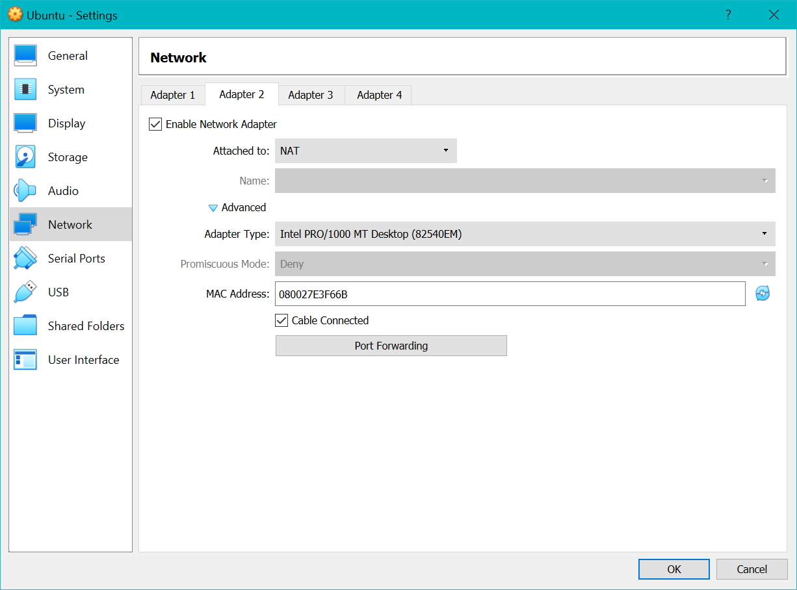
Click on Advanced
Click on Port Forwarding
Click on the green plus sign and add the first rule shown below
- Name: Web1
- Protocol: TCP
- Host Port: 80
- Guest Port: 80
Click on the green plus sign a second time and add the second rule shown below
- Name: Web2
- Protocol: UDP
- Host Port: 80
- Guest Port: 80
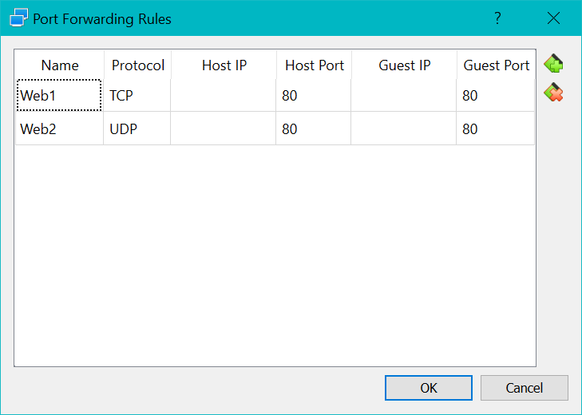
Click OK to save and exit
Start the virtual machine.
Now you should be able to browse to your Ubuntu web server using either your Windows host ip address or your Ubuntu guest web server ip address.
To find your Windows’ ip address, open a cmd window. Type in the command ipconfig. As shown below my Windows’ IPv4 ip address is 192.168.1.104
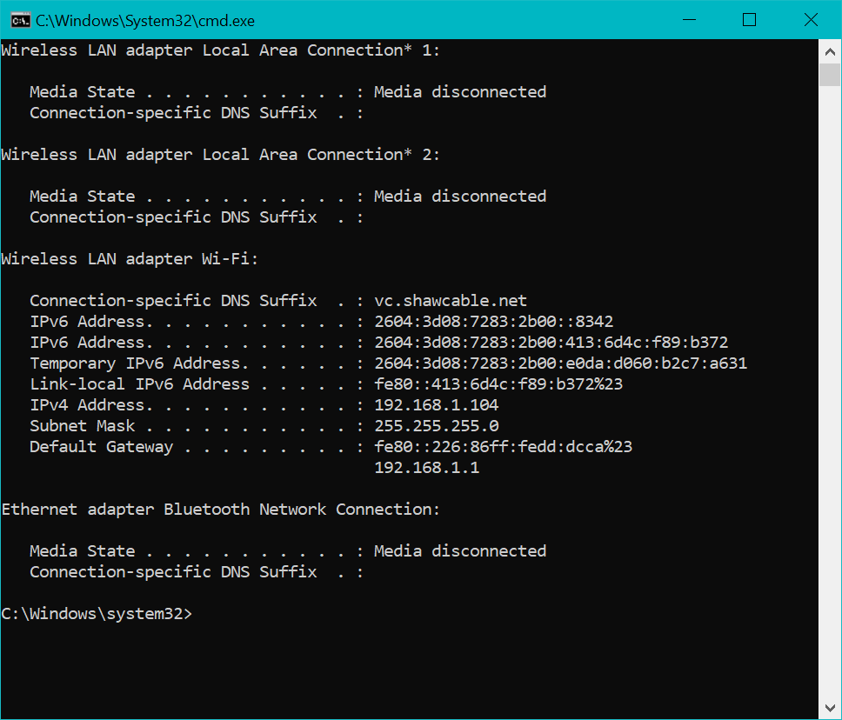
To find your Ubuntu’s ip address, open a terminal window. Type in the command ip addr. As shown below my Ubuntu’s IPv4 ip address is 192.168.1.63
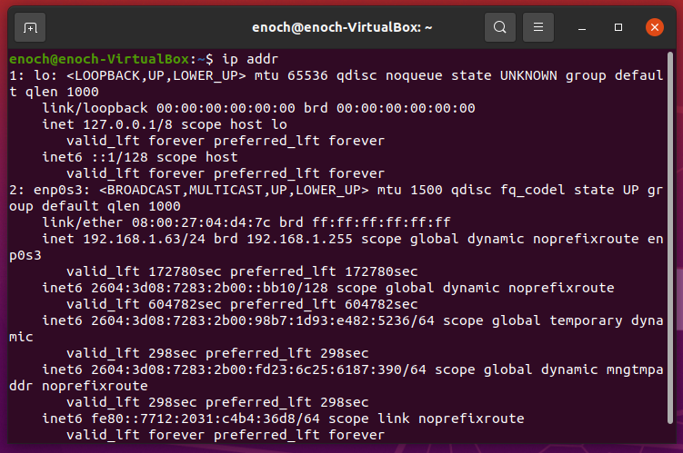

VirtualBox Shared Folders
From the VirtualBox menu, select Devices | Shared Folders | Shared Folders Settings
Click on the Add new shared folder icon. Select the Folder Path you want to share. Check Auto-mount and Make Permanent.
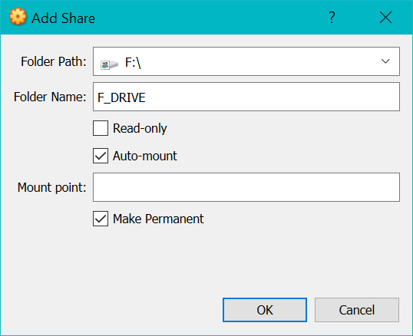

SSH Server
The Secure SHell (SSH) allows you to use a terminal to remotely login to your server. After you login, you will be able to work on your server from a remote computer as if you are directly using the server. In order to use SSH, you first need to install the SSH server on your Ubuntu machine by executing the following commands:
$ sudo apt update
$ sudo apt install openssh-server
To verify that SSH is active and running
$ sudo systemctl status ssh
Open the SSH port through the firewall to allow traffic through
$ sudo ufw allow ssh

SSH Client

Remote Ubuntu or Mac machine
From a remote Ubuntu machine open a terminal window and type ssh account@server_address at the prompt to connect to the server.
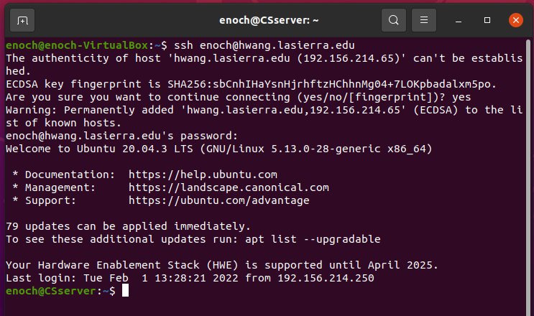

Remote Windows machine
From a remote Windows machine you need to first download PuTTY from putty.org and install it. Run the program. In the PuTTY Configuration window, type in the server address hwang.lasierra.edu and click Open.
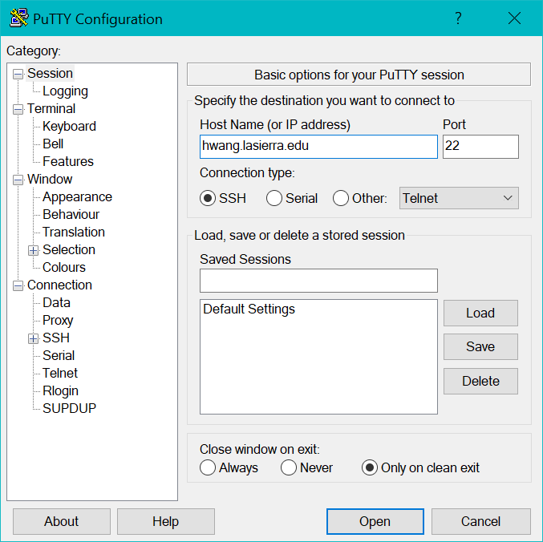
After the connection is established with a terminal window, you will need to login with your user account and password.

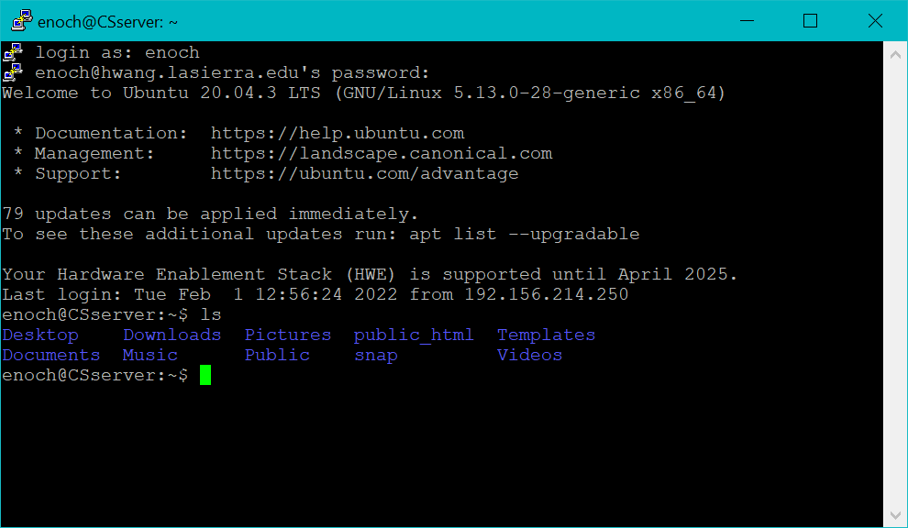

SCP
Secure copy a file from Windows to Linux. To use scp, you need to have installed SSH. From a Windows’ cmd window, type the scp command. The syntax of the command is scp fromFile toFile. The following are three examples of copying the file Enoch.jpg in the root directory of the C: drive to the directory public_html using the same name.
C:\scp c:/Enoch.jpg enoch@hwang.lasierra.edu:public_html/Enoch.jpg
C:\scp c:/Enoch.jpg enoch@hwang.lasierra.edu:public_html/.
C:\scp c:/Enoch.jpg
enoch@hwang.lasierra.edu:/home/enoch/public_html/Enoch.jpg

FTP
The File Transfer Protocol (FTP) is for copying files from one computer to another computer. In order to use FTP, you first need to install the FTP server vsftpd on your Ubuntu machine by executing the following commands:

$ sudo apt update
$ sudo apt install vsftpd
Reference: https://linuxize.com/post/how-to-setup-ftp-server-with-vsftpd-on-ubuntu-20-04/
To use FTP to copy a file from a remote computer, such as your Windows computer, to your Ubuntu computer, you run a FTP client program on your Windows computer. A popular free FTP client program is FileZilla. Download the FileZilla client program from https://filezilla-project.org/.
In the FileZilla Site Manager window, create a new site and fill in the host address, user name and password. Select SFTP for the Protocol.
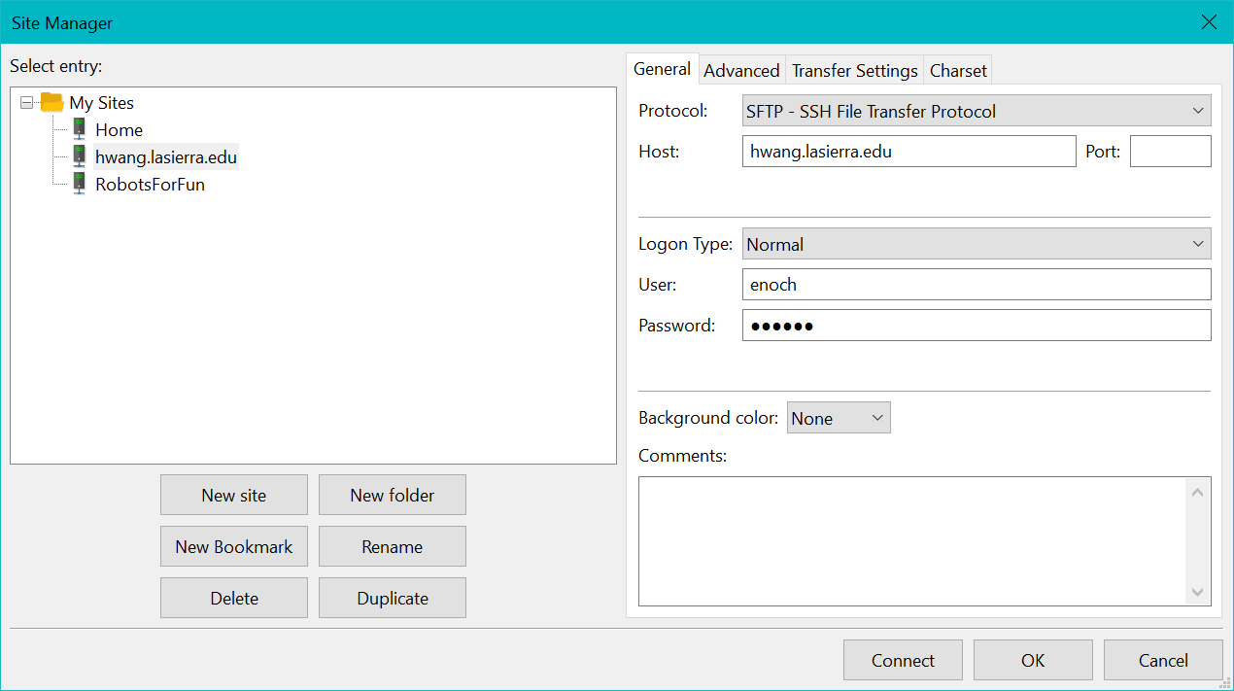
Click OK to save
Click Connect to connect to the server.
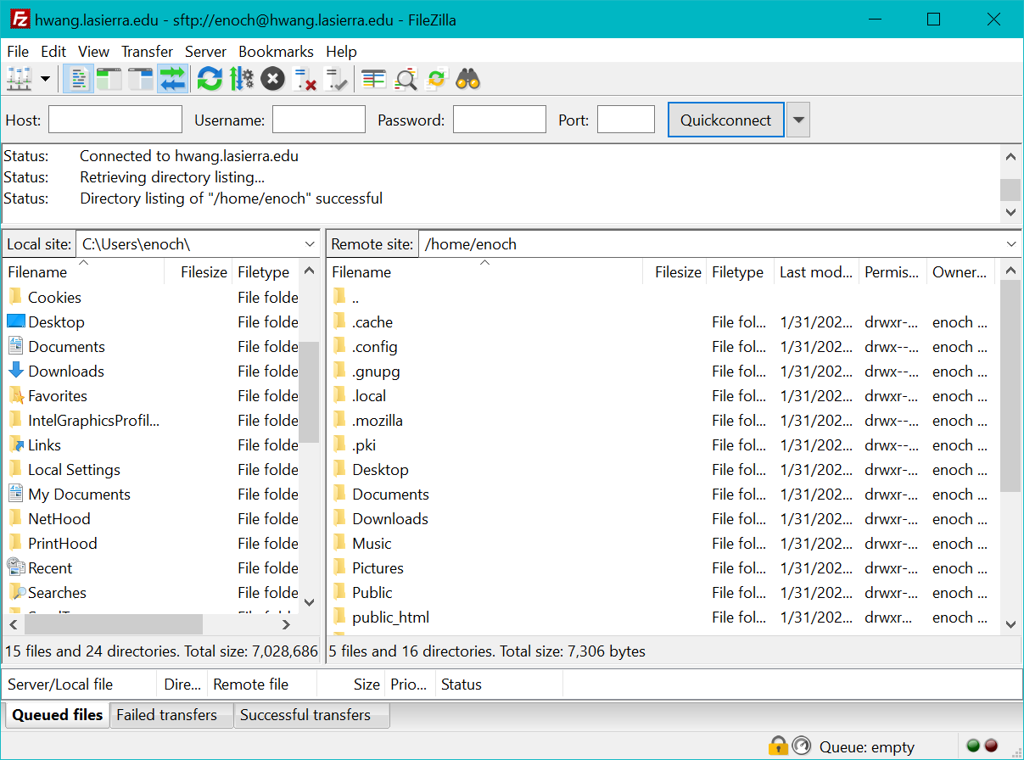

(Optional) Configure Apache to listen to another port
Port 80 is the default port for web browsing. If you want to use another port number you need to configure Apache to listen to this new number.
- Edit /etc/apache2/ports.conf
- Change the line Listen 80 to Listen 8081 where 8081 is the new port number that you want.
- Edit /etc/apache2/sites-enabled/000-default.conf
- Change the line <VirtualHost *:80> to <VirtualHost *:8081>
- Restart Apache.
$ systemctl restart apache2

- To check that Apache is using the new port number
$ sudo apt install net-tools
$ sudo netstat –tlpn | grep apache
It should print out a line that says 8081 apache2
To browse to your web server you now need to specify the port as part of the URL address in your browser. For example, 192.168.1.163:8081/index.html will use port 8081. If you don’t specify the port 8081, it will default to port 80 and the Apache web server will not respond.

Unix/Linux/Ubuntu Common Commands
Here are some Unix commands that you will commonly use. Unix commands are case sensitive. The first word is the command and the following words are parameters to the command.

Command | Operation | Example
cd | Go to your home directory | cd
cd /var/www/html | Change directory to /var/www/html | cd /var/www/html
cd .. | Go up one level | cd ..
pwd | Show current directory | pwd
cp fromfile tofile | Copy fromfile to tofile | cp in.txt index.html
mv fromfile tofile | Move/Rename fromfile to tofile | mv in.txt index.html
mkdir directory | Make (create) directory | mkdir images
rm filename | Remove (delete) file | rm in.txt
rm -r directory | Remove (delete) directory and everything inside it | rm -r images
chmod per file | Change read/write/execute permissions for a file or directory | chmod 777 index.html
nano file | Edit file | nano index.html
passwd | Change your account password | passwd
clear | Clear the terminal screen | clear
ping ip_address | Check connection to computer with given ip address | ping -4 google.com
ip addr | Get ip address of computer | ip addr
netstat | See what ports computer is listening on | netstat -a
Get more details on the commands here.

Port 80 is the default port for web browsing. If you use another number then you need to configure Apache to listen to this other number.

