MySQL
MySQL is a popular free database.
To enter MySQL, from the Linux Terminal window, type the following to login to the root account using the root password.
$ sudo mysql –u root –p
...
mysql> exit;
After you have created a new mysql user account, you can then login using the following
$ mysql –u useraccount –p
...
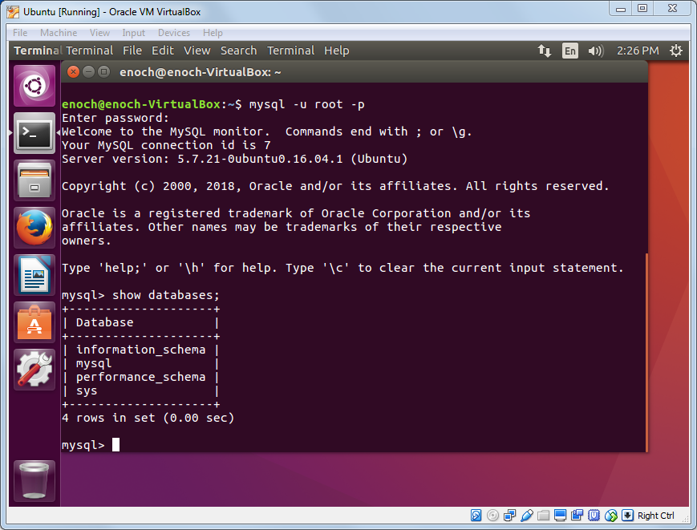

MySQL Common Commands
MySQL commands are not case sensitive, however, the user identifiers that you create are case sensitive. In the examples below the mysql keywords are in caps.

Commands | Examples
show databases | show databases;
show tables | show tables;
create database | create database sampleDB;
use | use sampleDB;
create table | create table Persons (PersonID int not null, FirstName varchar(255), LastName varchar(255), primary key (PersonID));  create table Devices (ID int not null auto_increment primary key, Mac varchar(255), Description varchar(255));
describe | describe Persons;
insert | insert into Persons (PersonID, FirstName, LastName) values (1, 'Enoch', 'Hwang');
select | select * from Persons;  select LastName from Persons where LastName = 'Hwang';
update | update Persons set FirstName = 'Windy' where PersonID = 1;
delete | delete from Persons where PersonID = 1;
alter | alter table Persons add Age int;  alter table Persons drop LastName;
drop database | drop database sampleDB;
drop table | drop table Persons;
exit

Administrative commands
Commands | Examples
create user | create user test@localhost identified by 'lsucs123';
drop user | drop user test@localhost;
grant all privileges | grant all privileges on sampleDB.* to test@localhost;  grant all privileges on `test%`.* to test@localhost;
flush privileges | flush privileges;
revoke all privileges | revoke all privileges on sampleDB.* from test@localhost;
show grants | show grants for test@localhost;

Examples | Comments
select user from mysql.user; | List all users
grant all privileges on test.* to test@localhost; | Can only create database named test.
grant all privileges on `test%`.* to test@localhost; | Can create any database with name starting with test. Note the back tick around `test%`
revoke all privileges on *.* from test@localhost;
To run a MySQL script name script.sql. The file is just a text file containing MySQL commands.
sudo mysql -u root -p < script.sql
or
mysql -u test -p < script.sql
Get the details on the commands here.

